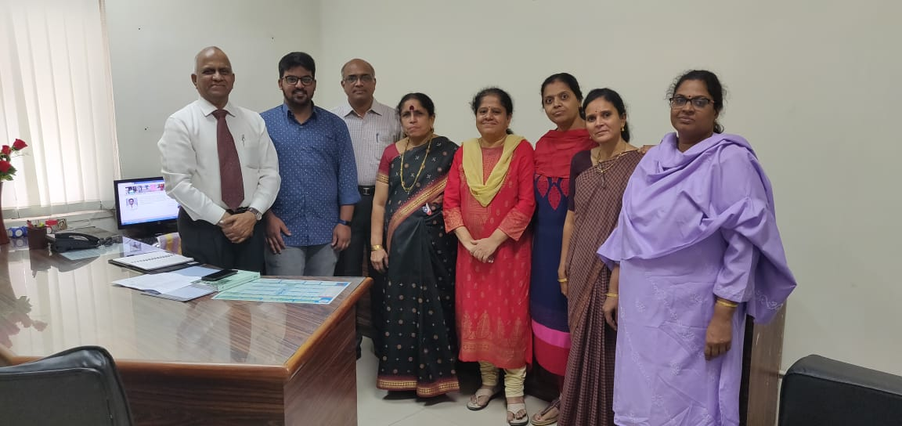
Mr Rehan secured Osmania University 7th Rank in B.sc , felicitated by Director General, Director and other faculty members.

